Mozeto Pizzas

Introduction
The Pizza Sales Analysis project focuses on analyzing pizza sales data to gain meaningful insights into the overall performance of a pizza business. In today's competitive business environment, data plays an important role in understanding customer preferences, identifying popular products, and making better business decisions. By analyzing sales data, businesses can understand what customers prefer and use these insights to improve their products and services.
This project uses four related datasets: Orders, Order Details, Pizzas, and Pizza Types. These datasets contain important information such as order dates and times, pizza types, sizes, prices, categories, ingredients, and quantities ordered. By combining these datasets, a complete view of the pizza sales process can be obtained.
The analysis is performed using SQL, which helps in organizing, querying, and analyzing the data efficiently. Different SQL concepts such as SELECT, WHERE, GROUP BY, ORDER BY, aggregate functions, JOINs, and subqueries can be used to answer various business-related questions.
The project aims to identify important sales patterns, including the total number of orders, most popular pizza types, preferred pizza sizes, top-selling products, category-wise distribution, and daily sales trends. These insights can help the business understand customer demand and identify which products perform well.
Overall, this project demonstrates how raw sales data can be transformed into useful and meaningful business insights. The results of the analysis can support better decision-making in areas such as menu planning, inventory management, sales strategy, and customer satisfaction.

Objectives
- To calculate the total number of orders and total revenue
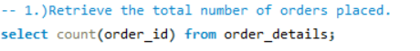

This objective focuses on evaluating the overall performance of the pizza business by calculating the total number of customer orders and the total revenue generated from pizza sales. The number of orders helps measure customer demand, while total revenue provides an understanding of the financial contribution of all pizzas sold. Together, these metrics give a clear overview of the overall business performance and sales activity.
- To identify the most popular pizza types and sizes
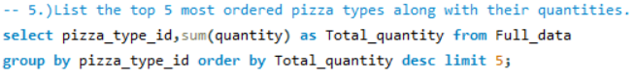
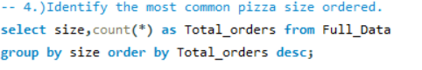

This objective aims to analyze customer preferences by identifying the pizza types and sizes that are ordered most frequently. By examining the quantity sold and number of orders for each pizza, the analysis can determine which products are most popular among customers. This information can help the business focus on high-demand pizzas and make better decisions regarding menu planning and inventory.
3. To analyze category-wise pizza sales
This objective focuses on comparing the sales performance of different pizza categories. By analyzing the number and quantity of pizzas ordered in each category, the project can identify which categories are more popular and contribute more to overall sales. This helps in understanding customer preferences and the performance of different product categories.

4. To analyze customer ordering patterns
This objective aims to understand how customer orders vary across different times and dates. By analyzing order dates, order times, and the average number of pizzas ordered per day, the project can identify patterns in customer demand and busy ordering periods. These insights can help the business improve staffing, inventory planning, and operational efficiency.

5. To identify the top-performing pizzas based on sales and revenue
This objective aims to identify the pizzas that contribute the most to the overall success of the business. The analysis compares different pizzas based on factors such as quantity sold, number of orders, and revenue generated. Identifying top-performing products can help the business prioritize popular items and develop effective sales and marketing strategies.

Insights
-- 1.)Retrieve the total number of orders placed.
Answer:


-- 2.)Calculate the total revenue generated from pizza sales.
Answer:
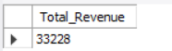

-- 3.)Identify the highest-priced pizza.
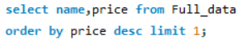
Answer:
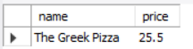

-- 4.)Identify the most common pizza size ordered.
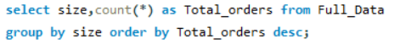
Answer:
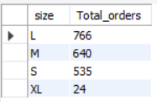
-- 5.)List the top 5 most ordered pizza types along with their quantities.
Answer:
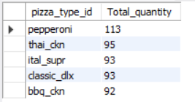

-- 6.)Join the necessary tables to find the total quantity of each pizza category ordered.
Answer:
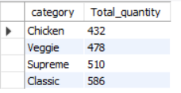
-- 7.)Determine the distribution of orders by hour of the day.
Answer:
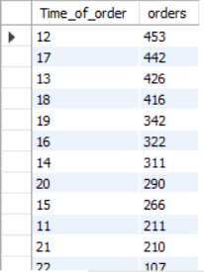

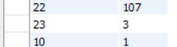

-- 8.)Join relevant tables to find the category-wise distribution of pizzas.
Answer:
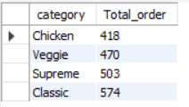

-- 9.)Group the orders by date and calculate the average number of pizzas ordered per day.
Answer:
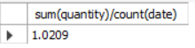

-- 10.)Determine the top 3 most ordered pizza types based on revenue.
Answer:
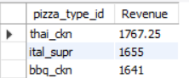

Dataset Description
This Pizza Sales Analysis project uses four related datasets: Orders, Order Details, Pizzas, and Pizza Types. Together, these datasets provide complete information about customer orders, the pizzas purchased, their sizes and prices, and the different types and categories of pizzas available.
1. Orders Dataset
The Orders dataset contains information about each customer order placed. It includes details such as the unique order ID, order date, and order time. This dataset is useful for analyzing daily sales patterns, identifying busy hours, and understanding when customers are most likely to place orders.
2. Order Details Dataset
The Order Details dataset contains detailed information about the individual pizzas included in each order. It includes the order details ID, order ID, pizza ID, and quantity ordered. This dataset connects customer orders with the specific pizzas purchased and is mainly used to analyze the number of pizzas sold and customer purchasing patterns.
3. Pizzas Dataset
The Pizzas dataset provides information about different pizza variations available for sale. It includes the pizza ID, pizza type ID, pizza size, and price. This dataset helps in comparing pizza sizes and prices and is useful for calculating the revenue generated from pizza sales.
4. Pizza Types Dataset
The Pizza Types dataset contains detailed information about each type of pizza. It includes the pizza type ID, pizza name, category, and ingredients used. This dataset helps in identifying popular pizza types, analyzing category-wise sales, and understanding the different products available in the menu.
All four datasets are connected through common fields such as Order ID, Pizza ID, and Pizza Type ID. By joining these datasets, a complete view of the pizza sales process can be created, allowing detailed analysis of sales performance, customer preferences, popular products, and overall business trends.

Conclusion
This Pizza Sales Analysis project successfully demonstrates how raw business data can be analyzed to generate meaningful insights and support better decision-making. By using the four related datasets—Orders, Order Details, Pizzas, and Pizza Types—a comprehensive analysis of customer orders, pizza sales, product categories, sizes, and revenue was performed.
The analysis helped identify important aspects of the business, such as the overall number of orders, total revenue generated, popular pizza types and sizes, category-wise sales distribution, customer ordering patterns, and top-performing pizzas. These insights provide a better understanding of customer preferences and show which products contribute most to the overall performance of the business.
The findings from this project can help a pizza business make more informed decisions regarding menu planning, inventory management, staffing, and sales strategies. For example, popular pizzas can be prioritized to ensure sufficient availability, while customer ordering patterns can help the business prepare for busy periods and manage resources more efficiently.
Overall, this project highlights the importance of SQL and data analysis in transforming raw data into valuable business insights. The analysis not only provides a clear understanding of past and current sales performance but can also serve as a foundation for future analysis, forecasting customer demand, and improving overall business performance.

